INTELLIGENT VISUAL INSPECTION AND RECOGNITION SYSTEM USING OPENCV
Industrial Surface Defect Detection and Quality Inspection

Course Code & Name: ITA0513 – Computer Vision
ABSTRACT
Manufacturing industries require reliable inspection systems to identify damaged or defective products before they reach customers. Manual inspection is slow, repetitive, and vulnerable to human error. This project presents an Intelligent Visual Inspection and Recognition System using Python and OpenCV for industrial surface defect detection and quality inspection. The functional prototype processes an input surface image through resizing, grayscale conversion, Gaussian filtering, CLAHE contrast enhancement, Canny edge detection, threshold-based segmentation, contour extraction, and defect visualization.
The prototype identifies significant abnormal regions using contour area and marks them with bounding boxes. The final decision is displayed as either “DEFECT DETECTED” or “GOOD PRODUCT”. Multiple intermediate outputs are generated so that preprocessing, segmentation, and feature analysis can be visually evaluated. Performance can be measured using processing latency, Frames Per Second (FPS), detection accuracy, precision, and recall when labelled test data are available.
A critical comparison is also made between traditional computer vision and deep learning. The current implementation provides a lightweight traditional baseline that is easy to execute on a normal CPU. However, a production-grade system requiring robust performance under large variations in lighting, orientation, texture, and product appearance should extend the baseline into a hybrid architecture by using a trained deep learning detector or classifier after OpenCV preprocessing. This approach balances real-time efficiency with adaptability and supports SDG 9, SDG 12, and SDG 8.

1. INTRODUCTION
Computer vision enables a computer to acquire, process, analyse, and interpret visual information from images and videos. In manufacturing, computer vision is increasingly used for automated quality inspection because production lines require fast, consistent, and repeatable decisions. Surface defects such as scratches, cracks, holes, stains, dents, and abnormal texture regions can reduce product quality and may lead to customer complaints or safety problems.
The proposed application is an Industrial Surface Defect Detection and Quality Inspection System. The system receives an image of a product surface and performs a sequence of image processing operations. First, the image is converted into a suitable representation. Noise is reduced using Gaussian Blur, contrast is improved using CLAHE, edges are extracted using the Canny operator, and segmentation is performed using thresholding. Contours are then extracted to identify significant abnormal regions. These regions are displayed using bounding boxes and labels.
The assignment also requires analysis of traditional computer vision and deep learning approaches. Therefore, this report treats the OpenCV contour-based solution as the functional baseline and proposes a hybrid extension in which deep learning performs more reliable defect classification or localization when product appearance becomes highly variable.

2. PROBLEM ANALYSIS
A technology firm intends to deploy an OpenCV-powered system for a real-world inspection environment. The system must operate with high detection or recognition performance while satisfying real-time constraints. Industrial environments introduce several practical disturbances: fluctuating illumination, shadows, reflections, changing object orientation, motion blur, camera noise, and structural differences between products.
A simple visual rule may work for one product image but fail when the background, illumination, or surface texture changes. This creates a trade-off. Traditional computer vision methods are fast and computationally lightweight, but their thresholds and handcrafted features may be brittle. Deep learning can learn complex defect patterns and generalize better when trained with representative data, but it increases the requirements for labelled datasets, training time, and hardware.
The engineering problem is therefore not merely to detect a dark or bright region. The goal is to design an end-to-end pipeline and justify an architecture that provides practical speed while improving robustness. The functional prototype in this project demonstrates the complete OpenCV processing flow, while the hybrid design describes how a deep learning model can be integrated for a production-level solution.

3. OBJECTIVES AND FUNCTIONAL REQUIREMENTS

3.1 Objectives
- Develop an operational visual inspection prototype using Python and OpenCV.
- Read an industrial surface image and prepare it for analysis.
- Apply image preprocessing using grayscale conversion, Gaussian filtering, and CLAHE.
- Perform segmentation using binary thresholding.
- Perform edge analysis using the Canny edge detector.
- Extract regions of interest using contour analysis.
- Identify significant abnormal regions using a contour-area rule.
- Visualize detected regions using bounding boxes and labels.
- Classify the overall sample as GOOD PRODUCT or DEFECT DETECTED.
- Evaluate the advantages and limitations of traditional and deep learning approaches.
- Propose a hybrid architecture suitable for a high-accuracy industrial deployment.

3.2 Functional Requirements
Requirement | Description | Status
Image input | Read industrial surface image | Implemented
Preprocessing | Resize, grayscale, blur, CLAHE | Implemented
Segmentation | Binary inverse thresholding | Implemented
Edge analysis | Canny edge detection | Implemented
Feature extraction | Contours and contour area | Implemented
Visualization | Bounding boxes and labels | Implemented
Final decision | Good product / defect detected | Implemented
Deep learning | Defect classifier or detector | Proposed hybrid extension
Real-time video | Camera or production line input | Future extension

4. COMPUTER VISION FUNDAMENTALS

4.1 Image Representation
A digital image is represented as a two-dimensional or three-dimensional array of pixel values. A grayscale image stores one intensity value per pixel, usually between 0 and 255. A colour image commonly contains three channels: Blue, Green, and Red. Converting to grayscale reduces computational complexity and is appropriate for many intensity-based inspection operations.

4.2 Sampling and Quantization
Sampling determines the spatial resolution of an image, while quantization determines the number of possible intensity levels. Insufficient resolution may hide small defects. Very high resolution improves detail but increases memory usage and processing time. A practical inspection system therefore selects a resolution that preserves relevant defects while supporting the required throughput.

4.3 Gaussian Filtering
Gaussian Blur smooths an image by averaging neighbouring pixel values according to a Gaussian distribution. It reduces small random noise and can make later edge and segmentation operations more stable. Excessive smoothing must be avoided because very small cracks or scratches may also be weakened.

4.4 CLAHE Enhancement
CLAHE stands for Contrast Limited Adaptive Histogram Equalization. Unlike global histogram equalization, CLAHE enhances contrast locally and limits excessive amplification. It is useful when illumination is uneven across the surface. However, CLAHE can also emphasize texture or noise, so its parameters must be selected carefully.

4.5 Edge Detection
The Canny algorithm identifies strong changes in image intensity. Such changes often occur at boundaries of cracks, scratches, holes, and other structural features. Edge maps are useful for visual analysis, but an edge alone does not prove that a region is defective. Normal product boundaries can also produce edges.

4.6 Segmentation and Contours
Thresholding converts a grayscale image into a binary representation according to an intensity rule. Connected regions can then be extracted as contours. The area and geometry of contours provide simple handcrafted features for identifying abnormal regions. This method is fast, but fixed thresholds are sensitive to changing illumination and product texture.

5. PROPOSED SYSTEM ARCHITECTURE
The functional prototype follows the following clear processing pipeline:
INPUT IMAGE
↓
IMAGE ACQUISITION USING OpenCV
↓
RESIZE
↓
GRAYSCALE CONVERSION
↓
GAUSSIAN BLUR
↓
CLAHE CONTRAST ENHANCEMENT
↓
CANNY EDGE DETECTION + THRESHOLD SEGMENTATION
↓
CONTOUR EXTRACTION AND AREA ANALYSIS
↓
BOUNDING BOX AND DEFECT LABEL
↓
FINAL DECISION: GOOD PRODUCT / DEFECT DETECTED
For the proposed hybrid production architecture, the contour-based stage can be used as a fast candidate-region generator. A deep learning classifier or detector can then verify whether the candidate region is a true crack, scratch, hole, stain, or normal texture. This reduces unnecessary deep learning inference and can improve computational efficiency.

6. METHODOLOGY AND PIPELINE IMPLEMENTATION

6.1 Input Acquisition
The system reads the file input.jpg using cv2.imread(). A validation check stops the program if the image cannot be loaded.

6.2 Resizing
The image is resized to 600 × 400 pixels. This provides a consistent working size and reduces processing requirements.

6.3 Grayscale Conversion
cv2.cvtColor() converts the BGR image into a single-channel grayscale image.

6.4 Gaussian Blur
A 5 × 5 Gaussian kernel is applied to reduce small-scale noise before enhancement and segmentation.

6.5 CLAHE Enhancement
CLAHE improves local contrast using clipLimit = 2.0 and tileGridSize = (8, 8).

6.6 Canny Edge Detection
Canny thresholds of 50 and 150 generate an edge map for structural inspection.

6.7 Threshold Segmentation
Binary inverse thresholding with a threshold value of 120 separates dark candidate regions from the background.

6.8 Contour Extraction
cv2.findContours() extracts connected candidate regions from the segmented image.

6.9 Feature Analysis
The contour area is used as a simple feature. Regions with area greater than 100 pixels are considered significant candidates.

6.10 Decision and Visualization
Bounding boxes and the label Defect are drawn around significant regions. If one or more candidate regions are found, the image status is DEFECT DETECTED; otherwise it is GOOD PRODUCT.

7. ALGORITHM
- Start the program.
- Read input.jpg.
- Check whether the image was loaded successfully.
- Resize the image to the selected processing resolution.
- Create a copy for final visualization.
- Convert the image to grayscale.
- Apply Gaussian Blur for noise reduction.
- Apply CLAHE for local contrast enhancement.
- Apply Canny edge detection.
- Apply threshold segmentation.
- Find contours in the threshold image.
- Initialize defect_count to zero.
- For each contour, calculate its area.
- Ignore contours smaller than the selected noise threshold.
- For significant contours, calculate a bounding rectangle.
- Draw the rectangle and label the region as Defect.
- Increase defect_count.
- If defect_count is greater than zero, set status to DEFECT DETECTED.
- Otherwise set status to GOOD PRODUCT.
- Display all intermediate and final outputs.
- End the program.

7.1 PSEUDOCODE
BEGIN
READ input image
IF image is not available THEN
PRINT error message
STOP
END IF
RESIZE image
COPY image to output
CONVERT image to grayscale
APPLY Gaussian Blur
APPLY CLAHE enhancement
APPLY Canny edge detection
APPLY threshold segmentation
FIND contours
SET defect_count = 0
FOR each contour
CALCULATE contour area
IF area > minimum_area THEN
CALCULATE bounding rectangle
DRAW rectangle on output
DISPLAY "Defect"
INCREMENT defect_count
END IF
END FOR
IF defect_count > 0 THEN
status = "DEFECT DETECTED"
ELSE
status = "GOOD PRODUCT"
END IF
DISPLAY original and intermediate images
DISPLAY final output
END

8. IMPLEMENTATION USING PYTHON AND OPENCV
The functional prototype was implemented using Python and OpenCV. NumPy is imported for numerical operations and future extensions. The program generates multiple output windows, allowing each stage of the computer vision pipeline to be demonstrated during evaluation.

8.1 Software Requirements
- Python 3.x
- OpenCV (opencv-python)
- NumPy
- Visual Studio Code or another Python IDE

8.2 Installation
pip install opencv-python numpy

8.3 Source Code
import cv2
import numpy as np
image = cv2.imread("input.jpg")
if image is None:
print("Error: input.jpg not found")
exit()
image = cv2.resize(image, (600, 400))
output = image.copy()
gray = cv2.cvtColor(image, cv2.COLOR_BGR2GRAY)
blur = cv2.GaussianBlur(gray, (5, 5), 0)
clahe = cv2.createCLAHE(
clipLimit=2.0,
tileGridSize=(8, 8)
)
enhanced = clahe.apply(blur)
edges = cv2.Canny(enhanced, 50, 150)
_, threshold = cv2.threshold(
enhanced,
120,
255,
cv2.THRESH_BINARY_INV
)
contours, _ = cv2.findContours(
threshold,
cv2.RETR_EXTERNAL,
cv2.CHAIN_APPROX_SIMPLE
)
defect_count = 0
for contour in contours:
area = cv2.contourArea(contour)
if area > 100:
x, y, w, h = cv2.boundingRect(contour)
cv2.rectangle(
output,
(x, y),
(x + w, y + h),
(0, 0, 255),
2
)
cv2.putText(
output,
"Defect",
(x, y - 10),
cv2.FONT_HERSHEY_SIMPLEX,
0.6,
(0, 0, 255),
2
)
defect_count += 1
if defect_count > 0:
status = "DEFECT DETECTED"
else:
status = "GOOD PRODUCT"
cv2.putText(
output,
status,
(20, 35),
cv2.FONT_HERSHEY_SIMPLEX,
1,
(0, 255, 0),
2
)
print("Number of possible defects:", defect_count)
print("Status:", status)
cv2.imshow("1 - Original Image", image)
cv2.imshow("2 - Grayscale", gray)
cv2.imshow("3 - Gaussian Blur", blur)
cv2.imshow("4 - CLAHE Enhancement", enhanced)
cv2.imshow("5 - Canny Edge Detection", edges)
cv2.imshow("6 - Threshold Segmentation", threshold)
cv2.imshow("7 - Final Defect Detection", output)
cv2.waitKey(0)
cv2.destroyAllWindows()

9. RESULTS AND OUTPUT INTERPRETATION
When the program is executed using the command python main.py, OpenCV processes the input image and opens multiple windows. These windows provide direct evidence that the required preprocessing, segmentation, and feature analysis stages are functioning.
Output Window | Operation | Purpose
1 - Original Image | Resized input | Shows the original inspection sample
2 - Grayscale | BGR to grayscale | Reduces image complexity
3 - Gaussian Blur | Noise filtering | Smooths small variations
4 - CLAHE Enhancement | Contrast enhancement | Improves local visibility
5 - Canny Edge Detection | Edge analysis | Highlights structural boundaries
6 - Threshold Segmentation | Binary segmentation | Separates candidate regions
7 - Final Defect Detection | Contours + bounding boxes | Shows inspection decision

9.1 Final Output








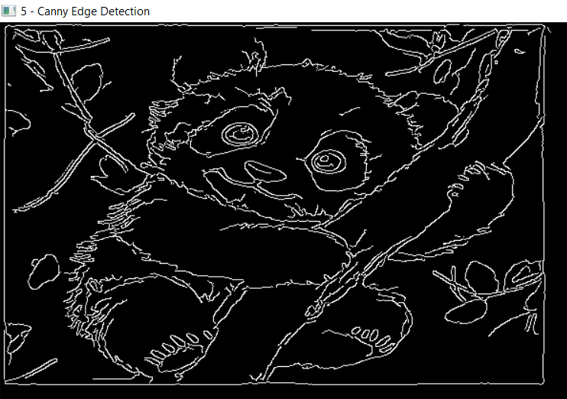

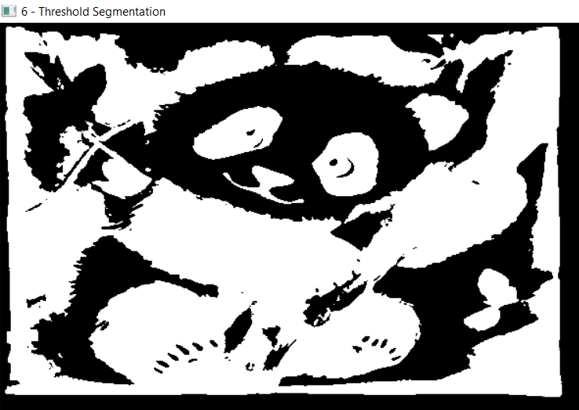

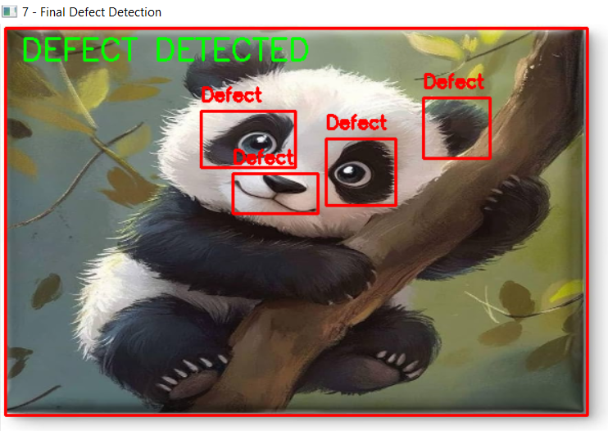

9.2 Interpretation
The pipeline demonstrates how a raw image can be progressively transformed into a decision. Preprocessing improves the suitability of the image for later operations. Segmentation identifies candidate regions, contour extraction converts those regions into measurable geometric objects, and visualization presents the result in a form suitable for an operator.

10. COMPARATIVE ANALYSIS: TRADITIONAL VS DEEP LEARNING

Parameter | Traditional OpenCV Pipeline | Deep Learning
Features | Handcrafted: edges, contours, texture, geometry | Automatically learned
Dataset need | Low for rule-based prototype | High; labelled examples are required
Training | No training required | Training and validation required
CPU requirement | Usually low | Moderate to high
GPU requirement | Not normally required | Preferred for training and fast inference
Speed | Generally fast | Depends on model size and hardware
Lighting robustness | Can be sensitive | Can improve with representative training
New defect types | Rules must be redesigned | Can be retrained with new examples
Interpretability | High | Often lower
Deployment | Simple and lightweight | Requires model management and optimization

11. PERFORMANCE EVALUATION
The current program provides a functional visual inspection prototype. A scientifically valid accuracy value cannot be claimed without a labelled test dataset and recorded predictions. Therefore, the report does not invent an accuracy value. For the production requirement of greater than 95%, the final hybrid model must be tested using a representative validation and test set.

11.1 Recommended Metrics
- Detection Accuracy = Correct Decisions / Total Samples × 100
- Precision = True Positives / (True Positives + False Positives)
- Recall = True Positives / (True Positives + False Negatives)
- F1 Score = 2 × Precision × Recall / (Precision + Recall)
- Latency = Total processing time / Number of processed frames
- FPS = Number of processed frames / Processing time

11.2 Example Evaluation Procedure
- Collect labelled images containing good and defective products.
- Split data into training, validation, and testing sets when using deep learning.
- Run the traditional baseline on the same test images.
- Record true positives, true negatives, false positives, and false negatives.
- Calculate precision, recall, F1 score, and accuracy.
- Measure average processing latency and FPS.
- Compare the baseline with the deep learning or hybrid system.
- Select the final architecture according to accuracy, throughput, hardware, and deployment constraints.

11.3 Processing Constraints
For a real production line, throughput should be measured on the actual deployment hardware. Image resolution, model size, camera frame rate, and number of products per minute directly affect the required FPS. A model that achieves high accuracy but cannot keep up with the production line is not a successful deployment solution.

12. HYBRID FRAMEWORK AND MODEL SELECTION
The recommended production architecture is a hybrid system. OpenCV performs fast image acquisition and preprocessing. Traditional operations can identify candidate regions or reject clearly normal frames. A deep learning model then classifies difficult regions or detects defect categories directly.
Camera / Production Image
↓
OpenCV Resize + Denoising + Illumination Correction
↓
Fast Candidate Region Analysis
↓
Deep Learning Classifier / Detector
↓
Defect Type: Crack / Scratch / Hole / Normal
↓
Confidence Score
↓
Accept / Reject Product
Possible deep learning choices include a custom CNN for image-level classification and a lightweight YOLO model for defect localization. The best choice depends on whether the factory needs only a pass/fail decision or also requires the exact location and type of each defect. A lightweight detector is preferable when real-time localization is required.

13. INDUSTRIAL RELEVANCE AND SDG MAPPING

13.1 Industrial Relevance
Automated visual inspection can improve consistency in manufacturing and reduce dependence on continuous manual observation. A system such as the proposed prototype can be adapted to inspect metal surfaces, electronic components, packaging, fabric, glass, printed materials, and other products where visual defects are important.

13.2 SDG 9 – Industry, Innovation and Infrastructure
The project supports intelligent industrial infrastructure by applying computer vision and automation to manufacturing quality inspection. Automated inspection contributes to innovation and modernized production processes.

13.3 SDG 12 – Responsible Consumption and Production
Earlier detection of defective products can reduce material waste, rework, and unnecessary transportation of poor-quality products. The technology can therefore contribute to more efficient production practices when implemented responsibly.

13.4 SDG 8 – Decent Work and Economic Growth
Automation changes repetitive inspection work and creates demand for skilled roles in software engineering, machine learning, data engineering, and industrial automation. The goal should be to support safer and more productive work rather than treat automation as a replacement for all human decision-making.

14. CHALLENGES, LIMITATIONS AND FUTURE SCOPE

14.1 Challenges
- Selecting a threshold that works under different lighting conditions.
- Distinguishing real defects from normal texture.
- Avoiding false detections caused by shadows and reflections.
- Detecting very small cracks without excessive noise.
- Balancing image resolution and processing speed.

14.2 Limitations of the Current Prototype
- The contour rule does not understand the semantic type of a defect.
- A fixed threshold may fail when illumination changes significantly.
- Normal product edges may be incorrectly identified as defects.
- The prototype is image-based and does not yet implement production-line video tracking.
- The current implementation is a traditional baseline; deep learning is proposed but not falsely claimed as already implemented.
- A greater-than-95% accuracy claim requires actual dataset evaluation.

14.3 Future Scope
- Train a CNN or YOLO-based defect detector using labelled industrial images.
- Integrate real-time camera or conveyor-belt video input.
- Use adaptive or learned illumination normalization.
- Add defect classes such as crack, scratch, hole, dent, and stain.
- Store inspection history in a database.
- Generate automatic quality-control reports.
- Use GPU acceleration for higher throughput.
- Deploy the application using edge devices for industrial environments.
16. CONCLUSION
This assignment developed an Intelligent Visual Inspection and Recognition System for industrial surface defect detection using Python and OpenCV. The functional prototype successfully demonstrates image acquisition, preprocessing, enhancement, edge analysis, threshold segmentation, contour extraction, feature analysis, and defect visualization. The program generates multiple output windows and produces a final quality decision.
The traditional OpenCV approach is computationally lightweight and suitable as a baseline. However, its dependence on manually selected thresholds and contour rules makes it vulnerable to significant changes in lighting, product texture, orientation, and unseen defect patterns. For a production environment with a high accuracy requirement, the recommended solution is a hybrid framework that combines OpenCV preprocessing with a trained deep learning classifier or detector. Such a system can balance real-time operational efficiency with improved adaptability and recognition capability.
The final production system should be evaluated using labelled industrial data and measured using accuracy, precision, recall, F1 score, latency, and FPS. Only after this evaluation can a greater-than-95% performance requirement be responsibly claimed.
project_report.docx

18. REFERENCES
- Zhao et al., “Surface Defect Detection in Machine Vision,” Computers, Materials & Continua, 2026.
- Zhang et al., “MCAM-Net for Industrial Surface Defect Detection,” The Visual Computer, 2026.
- Hu et al., “Machine Vision Based Industrial Defect Detection,” Scientific Reports, 2026.
- Li et al., “Metal Workpiece Surface Defect Detection System,” Measurement, 2026.
- Challa et al., “Image Preprocessing for Neural Network-Based Defect Detection,” Scientific Reports, 2026.

